

Directions to the Northern Kentucky University Health Innovation/Founders Hall Building Atrium

Directions to Campus https://www.nku.edu/about/directions.html
Traveling from Lexington, Kentucky:
Take I-75 North.
Continue on I-71/75 North
Take Exit 185 onto I-275 East
Follow directions for traveling East on I-275
Traveling East on I-275 from Greater Cincinnati / Northern Kentucky Airport:
Take Exit 76 (Three Mile Road/Northern Kentucky University)
Turn right off of the exit on University Drive
Turn right at the first stop light onto Kenton Drive.
Continue straight through campus.
Turn right into the Kenton Drive Parking Garage (Located directly across from the Student Union).
Parking – Kenton Drive Garage
Follow Kenton Drive until you can turn right into the Kenton Drive Garage (see orange arrow on map below). Take a parking ticket when entering the garage.

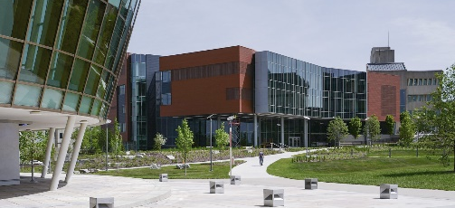
Directions to the Building/Meeting Room
The Health Innovation Center is the copper colored building next to Griffin Hall (see blue arrow on map below).
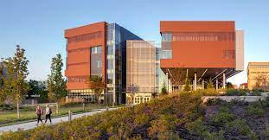
From the garage, the building will be on the left of Griffin Hall. You will see the walkway that leads to the front entrance (under the HIC sign). The atrium is on the lowest level.
Here is the web link to the interactive online map. https://map.nku.edu/#!BLD_2016050816627

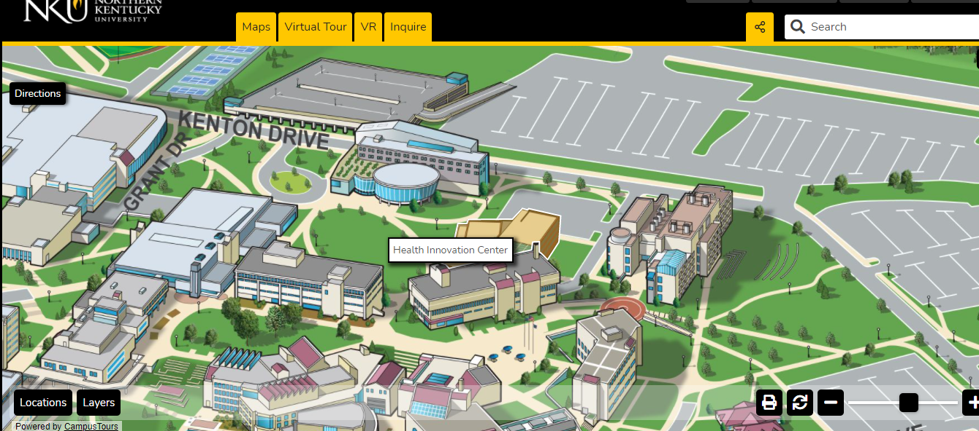
Kenton Parking Garage
Health Innovations Center

